55341 Lab 10: Implementing Network Load Balancing

Lab: Implementing NLB

**Scenario**

Adatum Corporation is an engineering and manufacturing company. The organization is based in London, England, and is quickly expanding into Australia. As the company expands, the need for scalable web applications has increased. To address this need, you need to develop a pilot program to test the deployment of NLB on hosts that are running the Windows Server 2022 operating system. Because you intend to automate the process of deploying Windows NLB clusters, you will use Windows PowerShell to perform many of the cluster setup and configuration tasks. You also will configure port rules and affinity, which will allow you to deploy multiple load-balanced web applications on the same NLB clusters.

Exercise 1: Implementing a Network Load Balancing (NLB) cluster

**Scenario**

You want to automate the process of deploying Windows Server 2022 NLB clusters. To accomplish this, you will use Windows PowerShell to perform the majority of the NLB cluster deployment tasks.

The main tasks for this exercise are as follows:

1. Verify website functionality for standalone servers.
2. Install NLB.
3. Create a new Windows Server 2022 NLB cluster.
4. Add a second host to the cluster.
5. Validate the NLB cluster.

Task 1: Verify website functionality for standalone servers

1. Switch to [**LON-SVR1**](urn:gd:lg:a:select-vm).
2. Send the [**CTRL+ALT+DEL**](urn:gd:lg:a:send-vm-key-combo) command and login on as [**Adatum\AdatumAdmin**](urn:gd:lg:a:send-vm-keys) with the password [**Pa55w.rd**](urn:gd:lg:a:send-vm-keys)

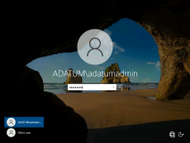

1. On [**LON-SVR1**](urn:gd:lg:a:select-vm), on the taskbar, click the **File Explorer** icon.

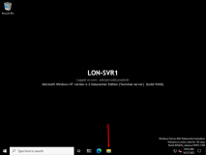

1. In the File Explorer address bar, browse to [**c:\inetpub\wwwroot**](urn:gd:lg:a:send-vm-keys)

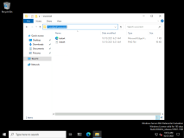

1. Double-click the file **iisstart.png** to open it in Microsoft Paint.

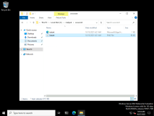

1. Ensure that the **Paintbrush** tool is selected.
2. Create a circle around the **IIS** logo.

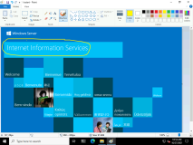

1. Save the changes that you made to **iisstart.png**, and then close **Microsoft Paint**.
2. Close **File Explorer**.
3. Switch to [**LON-DC1**](urn:gd:lg:a:select-vm)
4. Send the [**CTRL+ALT+DEL**](urn:gd:lg:a:send-vm-key-combo) command and login on as [**Adatum\AdatumAdmin**](urn:gd:lg:a:send-vm-keys) with the password [**Pa55w.rd**](urn:gd:lg:a:send-vm-keys)
5. Open **Microsoft Edge** from the taskbar.

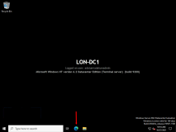

1. In the **Microsoft Microsoft Edge** Address Bar, type the address [**http://LON-SVR1**](urn:gd:lg:a:send-vm-keys), and then press Enter.
2. Verify that the webpage displays the IIS logo with the circle that you just added.

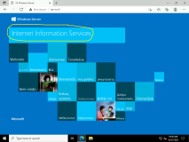

1. In the Microsoft Edge Address Bar, type the address [**http://LON-SVR2**](urn:gd:lg:a:send-vm-keys), and then press Enter.
2. Verify that the webpage does not display the IIS logo with the circle.

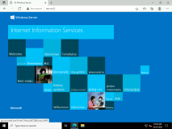

Task 2: Install NLB

1. Switch to [**LON-SVR1**](urn:gd:lg:a:select-vm)
2. Click **Start**, and then click **Windows PowerShell ISE**.

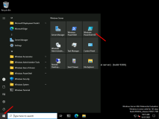

1. In the **Windows PowerShell ISE** window, type the following command to install NLB on **LON-SRV1** and **LON-SVR2**, and then press Enter:
2. Invoke-Command -Computername LON-SVR1,LON-SVR2 -command {Install-WindowsFeature NLB,RSAT-NLB}

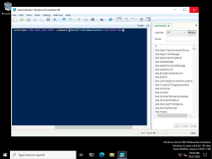

Task 3: Create a new Windows Server 2022 NLB cluster

1. On [**LON-SVR1**](urn:gd:lg:a:select-vm), in the **Windows PowerShell ISE** window, type the following command to create the new NLB cluster, and then press Enter:
2. New-NlbCluster -InterfaceName "Ethernet" -OperationMode Multicast -ClusterPrimaryIP 172.16.0.42 -ClusterName LON-NLB
3. In the **Windows PowerShell ISE** window, type the following command to add the NLB cluster to Domain Name System (DNS), and then press Enter:
4. Invoke-Command -Computername LON-DC1 -command {Add-DNSServerResourceRecordA -zonename adatum.com -name LON-NLB -Ipv4Address 172.16.0.42}

Task 4: Add a second host to the cluster

1. On [**LON-SVR1**](urn:gd:lg:a:select-vm), in the **Windows PowerShell ISE** window, type the following command to add a second host to the cluster, and then press Enter:
2. Add-NlbClusterNode -InterfaceName "Ethernet" -NewNodeName "LON-SVR2" -NewNodeInterface "Ethernet"

Task 5: Validate the NLB cluster

1. On [**LON-SVR1**](urn:gd:lg:a:select-vm), open **Server Manager** then click **Tools**, and then click **Network Load Balancing Manager**.

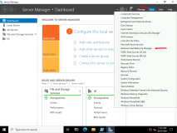

1. Click **OK** to dismiss the **Warning** message box, if it appears.
2. In the **Network Load Balancing Manager** window, click **LON-NLB (172.16.0.42)**.

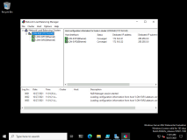

1. In the **Host configuration information for hosts in cluster LON-NLB (172.16.0.42)** pane, verify that the nodes **LON-SVR1** and **LON-SVR2** display with the status **Converged**.

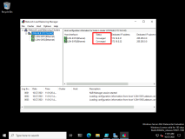

1. Right-click the **LON-NLB (172.16.0.42)** cluster, and then click **Cluster properties**.

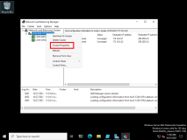

1. In the **LON-NLB(172.16.0.42) Properties** dialog box, on the **Cluster Parameters** tab, verify that the cluster is set to use the **Multicast** operations mode.

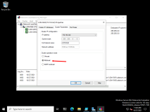

1. On the **Port Rules** tab, verify that there is a single port rule with a Cluster IP address of **All** that starts at port **0** and ends at port **65535** for both **TCP** and **UDP** protocols, and that it uses **Single** affinity.

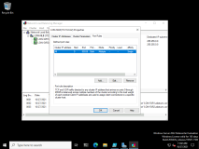

1. Click **OK** to close the **LON-NLB(172.16.0.42) Properties** dialog box.

**Results**: After completing this exercise, you should have successfully implemented an NLB cluster.

Exercise 2: Configuring and managing the NLB cluster

**Scenario**

As part of the pilot, you want to deploy multiple separate websites to the NLB cluster, and then differentiate these websites based on port address. To do this, you want to ensure that you can configure and validate port rules. You also want to experiment with affinity settings to ensure that requests are distributed evenly across the hosts.

The main tasks for this exercise are as follows:

1. Configure port rules and affinity.
2. Validate port rules.
3. Manage host availability in the NLB cluster.

Task 1: Configure port rules and affinity

Configure affinity for NLB cluster nodes

1. Switch to [**LON-SVR2**](urn:gd:lg:a:select-vm).
2. Send the [**CTRL+ALT+DEL**](urn:gd:lg:a:send-vm-key-combo) command and login on as [**Adatum\AdatumAdmin**](urn:gd:lg:a:send-vm-keys) with the password [**Pa55w.rd**](urn:gd:lg:a:send-vm-keys)



1. On [**LON-SVR2**](urn:gd:lg:a:select-vm), right click **Start**, and then click **Windows PowerShell (Admin)**.

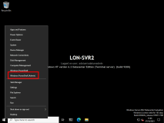

1. In the **Windows PowerShell** window, type the following commands and then press Enter:
2. Mkdir c:\porttest

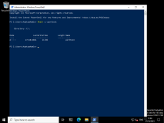

1. In the **Windows PowerShell** window, type the following commands and then press Enter:
2. Xcopy /s c:\inetpub\wwwroot c:\porttest

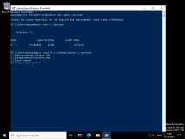

1. In the **Windows PowerShell** window, type the following commands and then press Enter:
2. New-Website -Name PortTest -PhysicalPath "C:\porttest" -Port 5678

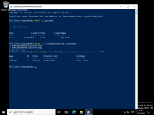

1. In the **Windows PowerShell** window, type the following commands and then press Enter:
2. New-NetFirewallRule -DisplayName PortTest -Protocol TCP -LocalPort 5678

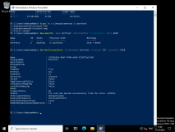

Configure NLB port rules

1. On the **Taskbar**, click the **File Explorer** icon.
2. In File Explorer, click drive **C**, double-click the **porttest** folder, and then double-click **iisstart.png** to open the file in **Microsoft Paint**.
3. Use the paintbrush to place a line across the **IIS** logo.

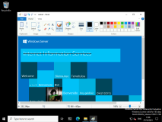

1. Save the changes to **iisstart.png**, and then close **Microsoft Paint**.
2. Switch to [**LON-DC1**](urn:gd:lg:a:select-vm)
3. In the Microsoft Edge Address Bar, type [**http://LON-SVR2:5678**](urn:gd:lg:a:send-vm-keys) and then press Enter.
4. Verify that the **IIS Start** page displays the IIS logo with a line across it.

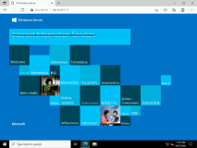

1. Switch to [**LON-SVR1**](urn:gd:lg:a:select-vm)
2. On [**LON-SVR1**](urn:gd:lg:a:select-vm), switch to **Network Load Balancing Manager**.
3. In the **Network Load Balancing Manager** console, right-click **LON-NLB(172.16.0.42)**, and then click **Cluster Properties**.

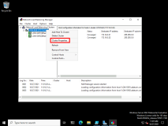

1. In the **LON-NLB (172.16.0.42) Properties** dialog box, on the **Port Rules** tab, select the **All** port rule, and then click **Remove**.

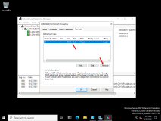

1. On the **Port Rules** tab, click **Add**.
2. In the **Add/Edit Port Rule** dialog box, type the following information, and then click **OK** :
   * Port range: [**80**](urn:gd:lg:a:send-vm-keys) to [**80**](urn:gd:lg:a:send-vm-keys)
   * Protocols: **Both**
   * Filtering mode: **Multiple host**
   * Affinity: **None**
3. On the **Port Rules** tab, click **Add**.
4. In the **Add/Edit Port Rule** dialog box, type the following information, and then click **OK** :
   * Port range: [**5678**](urn:gd:lg:a:send-vm-keys) to [**5678**](urn:gd:lg:a:send-vm-keys)
   * Protocols: **Both**
   * Filtering mode: **Single host**

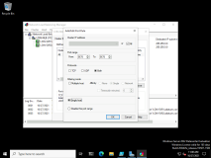

1. Click **OK** to close the **LON-NLB(172.16.0.42) Properties** dialog box.

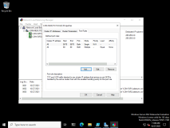

1. In the **Network Load Balancing Manager** console, right-click **LON-SVR1 (Ethernet)**, and then click **Host Properties**.

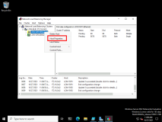

1. On the **Port Rules** tab, click the port rule that has **5678** as the **Start** and **End** value, and then click **Edit**.

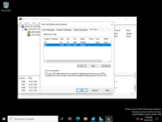

1. In the **Handling priority** list, click **10**.

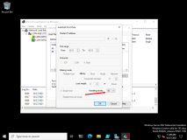

1. Click **OK** twice to close both the **Add/Edit Port Rule** dialog box and the **LON-SVR1 (Ethernet) Properties** dialog box.

Task 2: Validate port rules

1. Switch to [**LON-DC1**](urn:gd:lg:a:select-vm)
2. In the Microsoft Edge Address Bar, type [**http://lon-nlb**](urn:gd:lg:a:send-vm-keys), and then press Enter.
3. Click the **Refresh** icon 20 times.
4. Verify that you see web pages both with and without the circle you added.
5. In the Microsoft Edge Address Bar, type the address [**http://LON-NLB:5678**](urn:gd:lg:a:send-vm-keys), and then press Enter.
6. Click the **Refresh** icon 20 times.
7. Verify that now only the web page with the distinctive line displays.

**Note:** It is possible that you will need to refresh your browser more than 20 times to see the different logos on **http://lon-nlb**.

Task 3: Manage host availability in the NLB cluster

1. Switch to [**LON-SVR1**](urn:gd:lg:a:select-vm)
2. In the **Network Load Balancing Manager** console, right-click **LON-SVR1 (Ethernet)**, click **Control Host**, and then click **Suspend**.

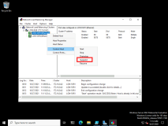

1. Click the **LON-NLB (172.16.0.42)** node. Verify that the node **LON-SVR1** displays as **Suspended**, and that the node **LON-SVR2** displays as **Converged**.

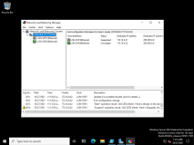

1. Right-click **LON-SVR1(Ethernet)**, click **Control Host**, and then click **Resume**.
2. Right-click **LON-SVR1(Ethernet)**, click **Control Host**, and then click **Start**.
3. Click the **LON-NLB (172.16.0.42)** node. Verify that both the nodes **LON-SVR1** and **LON-SVR2** now display as **Converged**.

**Note:** You might have to refresh the view.

**Results**: After completing this exercise, you should have successfully configured and managed an NLB cluster

Exercise 3: Validating high availability for the NLB cluster

**Scenario**

As part of preparing to deploy NLB in your organization's environment, you want to ensure that it is possible to perform maintenance tasks such as reboot operations without affecting the availability of the websites that are hosted on the cluster. To accomplish this, you decide to verify availability by rebooting one host while you attempt to access the clustered website. You also will explore the Drainstop functionality.

The main tasks for this exercise are as follows:

1. Validate website availability when the host is unavailable.
2. Configure and validate Drainstop.
3. Prepare for the next module.

Task 1: Validate website availability when the host is unavailable

1. On [**LON-SVR1**](urn:gd:lg:a:select-vm), in the **Windows PowerShell** window, type the following command, and then press Enter:
2. restart-computer
3. Switch to [**LON-DC1**](urn:gd:lg:a:select-vm)
4. In the Microsoft Edge Address Bar, type [**http://LON-NLB**](urn:gd:lg:a:send-vm-keys) and then press Enter.
5. Refresh the website 20 times.
6. Verify that the website is available while **LON-SVR1** reboots, and verify that it does not display the **IIS** logo with the circle until **LON-SVR1** restarts.

Task 2: Configure and validate Drainstop

1. Switch to [**LON-SVR1**](urn:gd:lg:a:select-vm).
2. Send the [**CTRL+ALT+DEL**](urn:gd:lg:a:send-vm-key-combo) command and login on as [**Adatum\AdatumAdmin**](urn:gd:lg:a:send-vm-keys) with the password [**Pa55w.rd**](urn:gd:lg:a:send-vm-keys)



1. Click **Start**, and then click the **Server Manager** tile.
2. In Server Manager, click **Tools**, and then click **Network Load Balancing Manager**.
3. In the **Network Load Balancing Manager** console, right-click **LON-SVR2(Ethernet)**, click **Control Host**, and then click **Drainstop**.
4. Switch to [**LON-DC1**](urn:gd:lg:a:select-vm)
5. In the Microsoft Edge Address Bar, type [**http://LON-NLB**](urn:gd:lg:a:send-vm-keys) and then press Enter.
6. Refresh the site 20 times, and then verify that only the **Welcome** page with the circled IIS logo displays.

**Results**: After completing this exercise, you should have successfully validated high availability for the NLB cluster.

**Congratulations!** You have now completed this lab. To continue to the next lab click End Lab in the Tools Menu . If you wish to contiue with this lab at a later date ensure you save the lab environment rather than ending it.